IOT Flood monitoring & Early warning ibm

# Introduction:

In a peninsular country like India, with extreme weather and climatic conditions, the occurrence of heavy rainfall is normal. Multiple times, the arrival of very heavy rains results in the heavy discharge of water or because of the sudden melting of the glaciers due to global warming. Especially, in the monsoon which normally begins in the mid of June and lasts till October, thousands of people lost their lives by drowning and their habitats were collapsed. The left our were evacuated by the state and central disaster relief authorities. The severe water logging brought daily work to halt. In order to save the lives of the people, their habitat and the economy, the major step is to monitor the data on real time basis and if the situation is reaching a certain threshold, then alert is to be provided to each individual living in the area which is currently at risk. Even if it is difficult to abandon the natural calamity but the mandatory steps are to be taken by the government agencies to shift the population to a safe region and the losses will get reduced to less than 30%.

In this modern era, there are multiple systems working and are deployed at different locations but the alert notification is passed to government agencies and this ends up in slowing down the process. The reason behind this is that flood is very spontaneous disaster and government agencies have to follow multiple steps before reaching to a decision. In this case, awareness among the people is very necessary along with the government officials. So that a combined and better result will be achieved. In our system, it is combined with prediction through weather forecasting. The flow of water is sensed by water flow sensor which will ultimately help in evaluating the intensity of flood and water level by the help of ultrasonic sensor which will be done by propagating sound waves. All these information will be showcased in the application.

The android application will be developed using Java, XML, Android studio. The application not only includes the data from IOT but also includes weather forecasting. The weather information will be gathered using Open Weather API which will provide real time climatic information. This will result in the avoidance of loss to mankind and economy as well.

# Purpose:

The main purpose of the initiative was to develop a location specific early warning system which could help the administration in taking advance precautionary measures and issue flood alerts to those specific areas so that necessary measures can be undertaken by the people.

With this purpose the project was initiated keeping in view the following objectives

1. Issue of alert for possible flood situation in district/Circle level with best possible lead time.
2. Submission of annual periodic report on status of existing embankments.
3. Creating an environment of joint participation among all stakeholders in order to generate actionable product for management of flood in Assam
4. Development of optimum methodology for rainfall prediction from satellite based weather monitoring and numerical weather prediction models supported by insitu ground data.
5. Development of river specific rainfall-runoff models for forecasting of flood.
6. Development of inundation simulation for flood plain zonation.

**Literature Survey:**

# Existing system:

In previous scenarios, performance of many flood forecasting system in an operational context is sub optimal and often below expectation .The information they designed to provide fail to reach

much of the target audience. Existing flood warning systems even with their manifest deficiencies can be effective in the mitigation of flood damage. In India most of the techniques for formulating the real time flood forecast are based on statistical approach. For some project network model and multi parameter hydrological model are used. Conventional systems of communication are normally used for transmitting the data in real time. Flash floods are usually experienced. As such there is no system for formulating the flash flood forecast. It results in heavy losses of lives and properties.

# Proposed system:

There are many earlier works provided by the researchers in the field of IOT but most of them either lacks precision or they are highly expensive. Thus, they are inaccessible to the user. In this module, we are making a device which will sense the possibility of flood, firstly by analyzing values from the IOT device and then checking the weather forecast. The work will not end here, it will keep on reading the values at each and every second and updating if it is higher than threshold. So, by installing it now you can easily save your life as well as your society.

# Block Diagram:

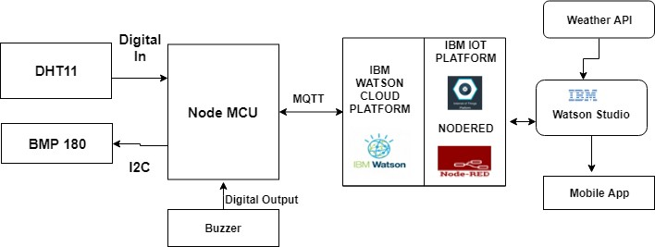

Fig.1: Block Diagram

# Software/Hardware Designing:

The hardware part of the project involves the ESP8266 model. The sensors DHT11, BMP180 and buzzer are connected to the ESP8266.

The software part of the project involves cloudant DB, Nodered, IBM Watson cloud Platform, iot IBM platform and Web/Mobile app.

# Experimental investigations:

There are several IoT authentication challenges and issues that need to be understood before employing the right security solution that can dynamically vary with the situation based on certain critical situations such as IOT forecasting applications, flood forecasting and early detection are necessary and cloud dynamically vary, potentially resulting in changes to the authorization of iot devices. To protect from floods we used such parameters as temperature, humidity and pressure by using these parameters we can give early warning of floods.

# Flow chart:

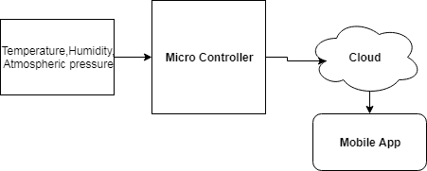

**Code using device simulater:**

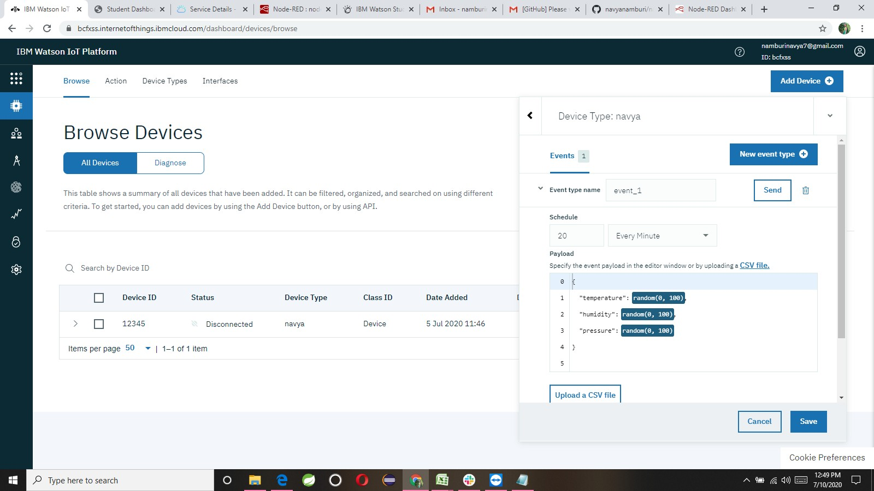

# Nodered:

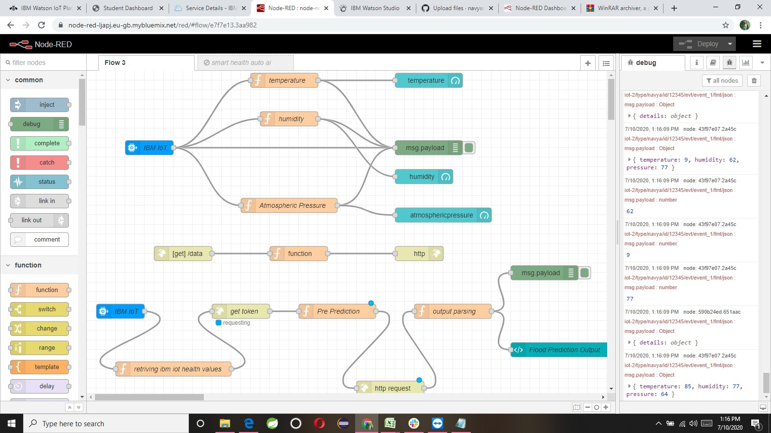

**Mit app designer:**

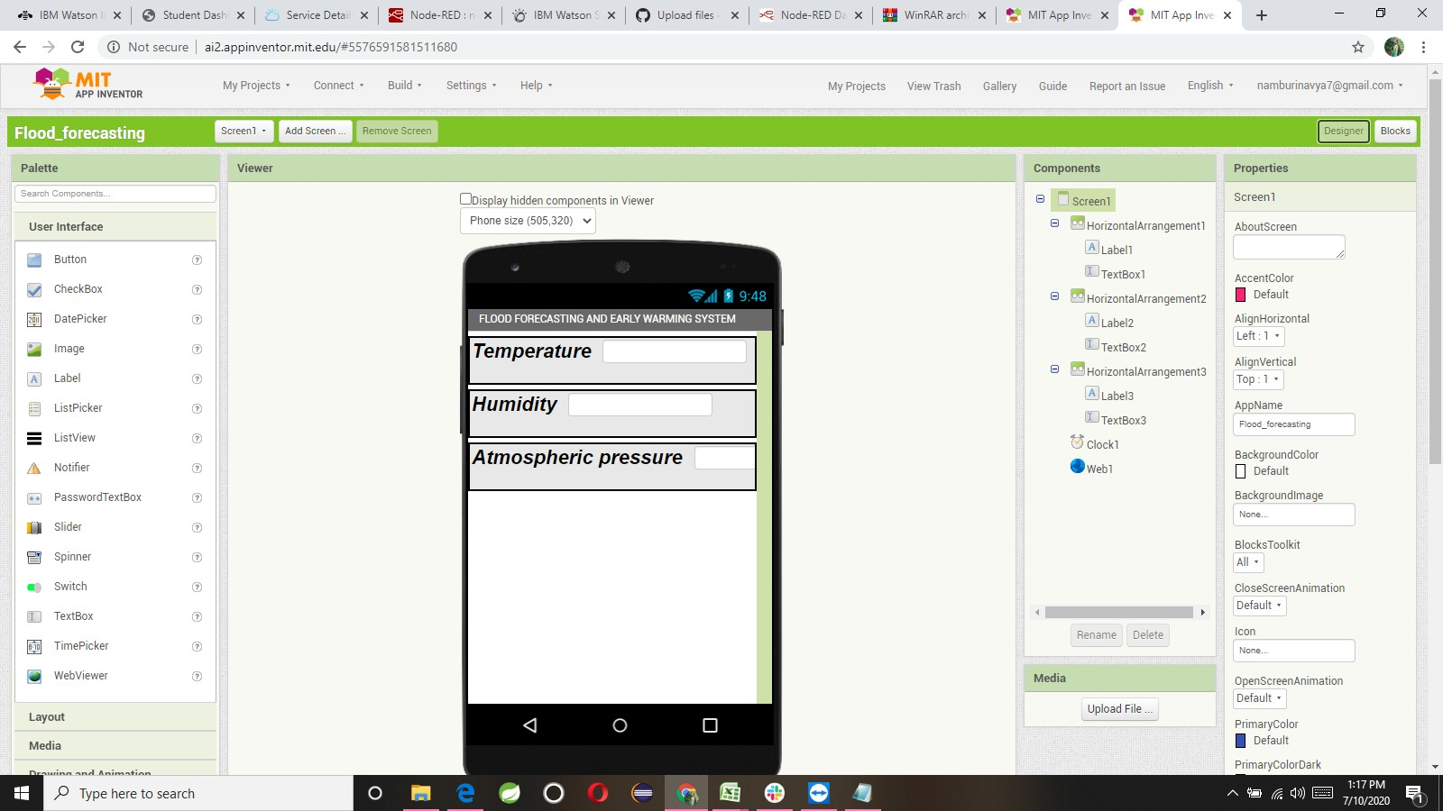

Mit app Blocks:

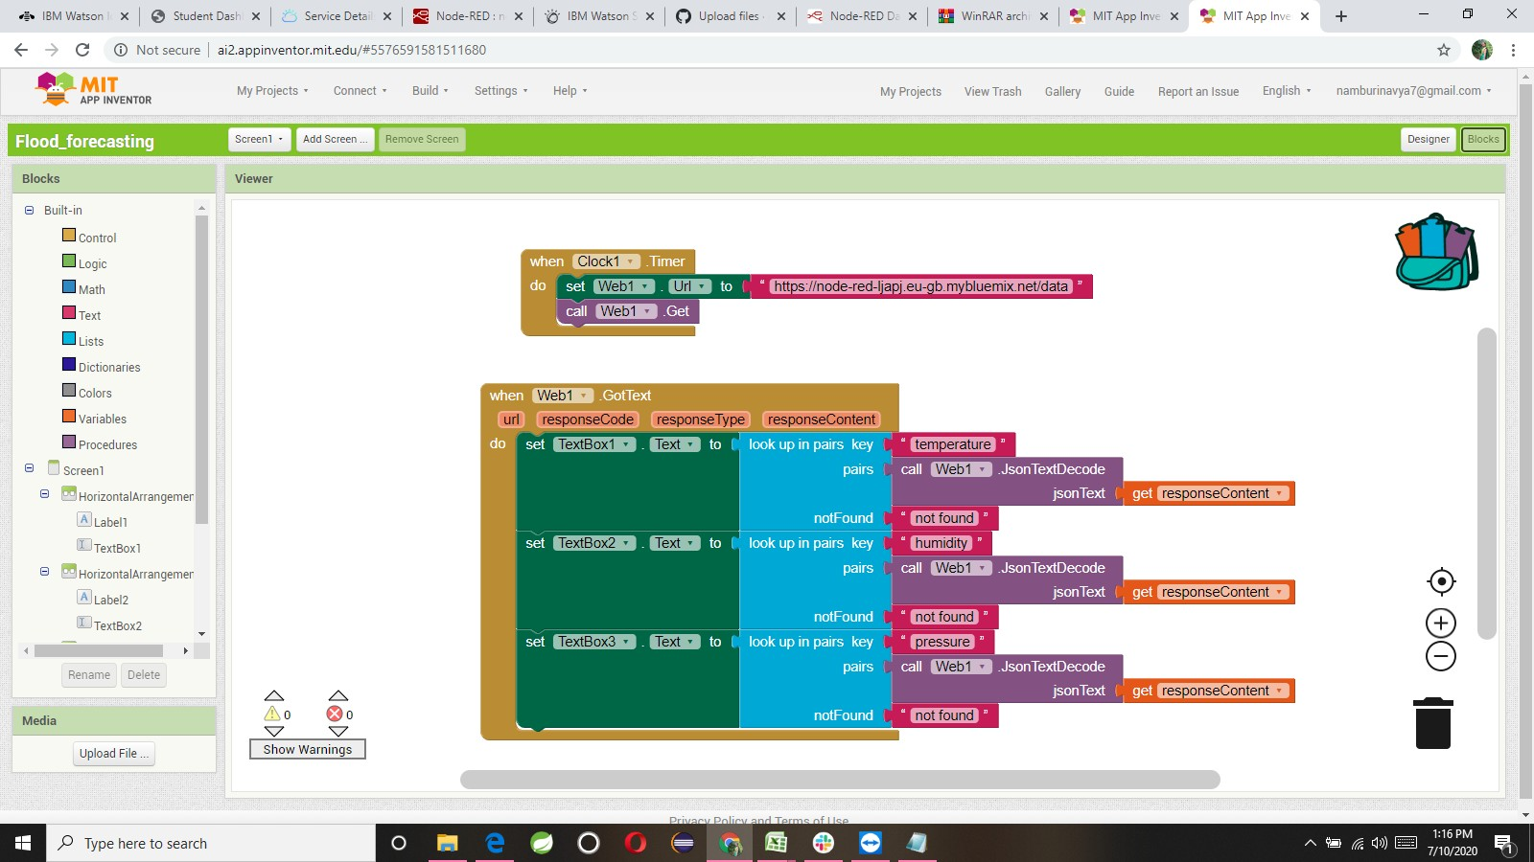

# Result:

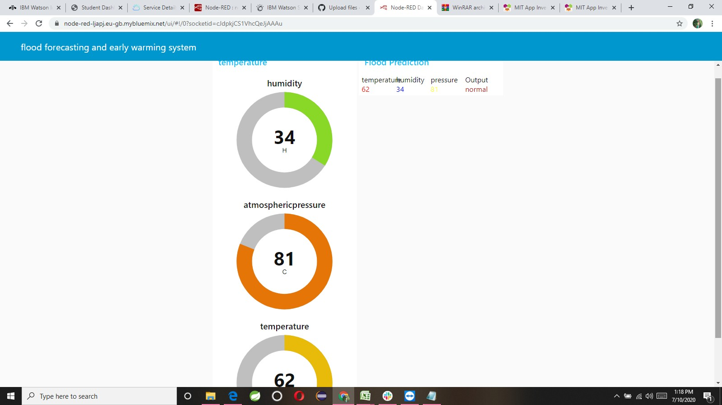

**Final Result:**

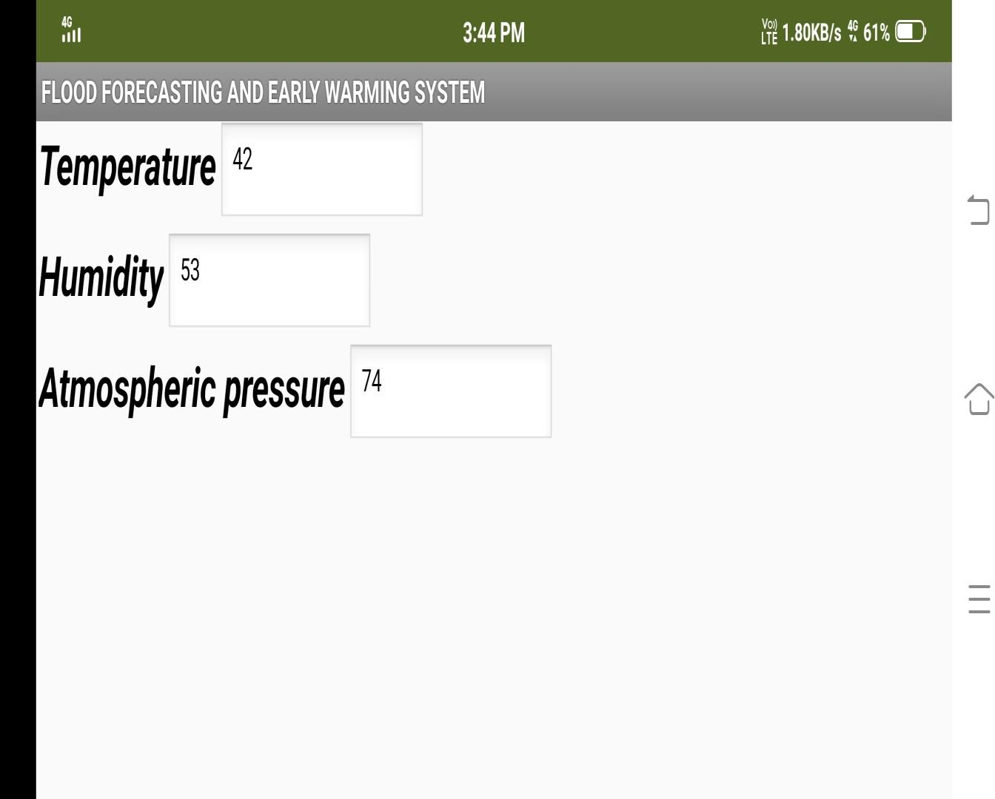

# Advantages and Disadvantages:

**Advantages of IoT in Flood Forecasting:**

* The impact of flooding is reduced
* Warnings give people time to move possessions upstairs, put sandbags in position and to evacuate

# Disadvantages of IoT in Flood Forecasting:

* Warnings don't stop a flood from happening
* Living in a place that gets lots of warnings could make it difficult to get insurance
* People may not hear or have access to warnings

# Conclusion:

Cloud software can be used in developing the flood forecasting and warning system with the presence of real time and forecasted rainfall from ground and satellite.

# Future scope:

Making a modular system which could be a part of system and can give a real time positioning of flood water.